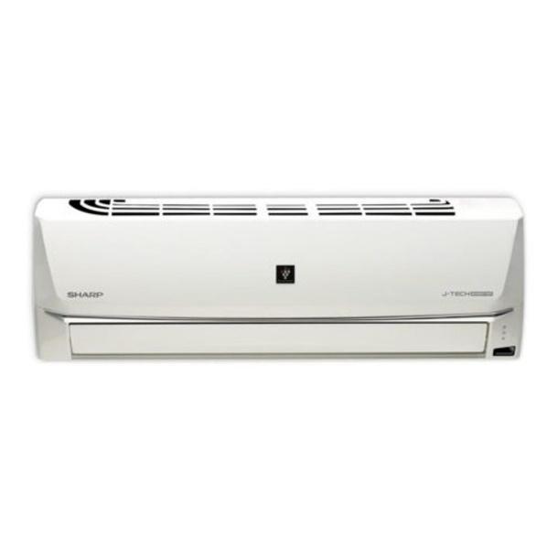

Sharp 2 Ton Inverter Split AC with Air Purification Cool Only 24SHV

Product details of Sharp 2 Ton Inverter Split AC with Air Purification Cool Only 24SHV

* Plasma cluster Ions
* Powerful Jet
* Gentle Cool Air System
* Auto Swing
* Self-Cleaning Function
* Quiet Operation
* Available Capacity
* 24,000 Btu (50Hz)
* Made in Thailand
* Capacity (Btu/Hr): 21325
* Voltage Range (v): 220-240
* Running Current:(A): 8.9
* Power Input (W): 1800
* EER : 11.85
* Dimension WxHxD: Indoor (1006 X 316 X 249), Outdoor (850 X 710 X 330)
* Standard Pipe length: 5 m
* Maximum pipe length: 15 m
* Refrigerant: R410A
* Compressor type: Rotary